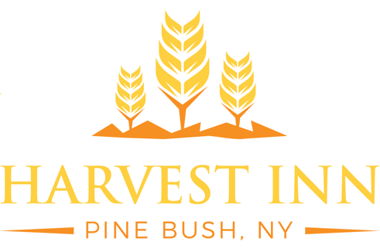

Shuttle Service

Bethel Complexes
- Wallkill $7.00 (Per person, roundtrip)
- Patterson or $70.00 (Single rider; 5 hours, roundtrip)
Warwick $90.00 (Single rider; 8 hours, roundtrip)
$35.00 (Per person, min 2 people, 5 hours, roundtrip)
$45.00 (Per person, min 2 people, 8 hours, roundtrip)
Airports
- Newark $75.00 (Per person, each way)
- LaGuardia $75.00 (Per person, each way)
- JFK $80.00 (Per person, each way)
- Stewart $45.00 (1-6 people; each way)
Train Stations
- Beacon $35.00 (1-6 people; each way)
- Middletown $25.00 (1-6 people; each way)
New York City
- Midtown $90.00 (Single rider; drop-off or pickup only)
$45.00 (Per person, min 2 people; drop-off or pickup only)
- Half Day $240.00 (1-6 people; 6 hours)
- All Day $340.00 (1-6 people; 12 hours)

Please see the Travel Desk for additional assistance, scheduling, or routes not listed. The direct phone number and email for the Travel Desk is listed below.

95 Boniface Dr. | Pine Bush, NY 12566 | (845)744-5700 ext. 322 | travel@harvest-inn.com

